**Source Code:**

**Q1. Determine whether the system is linear or nonlinear. Plot the required signals to verify results. Consider two signals x1[n]=n and x2[n]=sin[n]**

**(a)y[n]=x^2[n]**

clc;

close all;

clear all;

a1=3;

a2=-7;

n=-3:0.1:3;

x1=n;

x2=sin(n);

y1=x1.^2;

y2=x2.^2;

y3= a1*y1 + a2*y2;

x3=a1*x1+a2*x2;

y4=x3.^2;

subplot(2,1,1);

stem(n,y3);

xlabel('n');

ylabel('y3[n]');

title('verify linearity/Shubham/034');

grid on;

subplot(2,1,2);

stem(n,y4);

xlabel('n');

ylabel('y4[n]');

title('verify linearity/Shubham/034');

grid on;

**Output:**

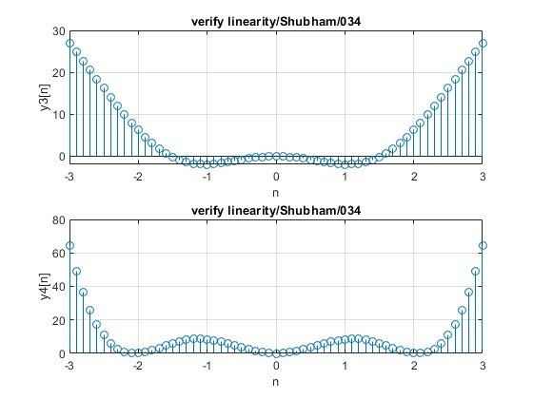

**(b) y[n]=x[n^2]**

clc;

close all;

clear all;

a1=3;

a2=-7;

n=-3:0.1:3;

x1=n;

x2=sin(n);

y1=n.^2;

y2=sin(n.^2);

y3= a1*y1 + a2*y2;

x3=a1*x1+a2*x2;

y4=a1.*n.^2+a2.*sin(n.^2);

subplot(2,1,1);

stem(n,y3);

xlabel('n');

ylabel('y3[n]');

title('verify linearity/Shubham/034');

grid on;

subplot(2,1,2);

stem(n,y4);

xlabel('n');

ylabel('y4[n]');

title('verify linearity/Shubham/034');

grid on;

**Output:**

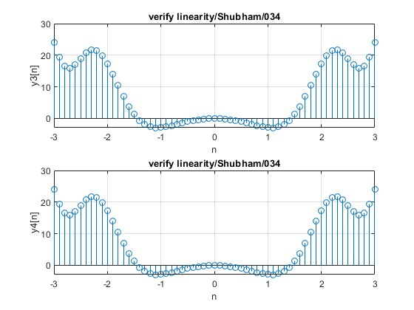

**(c) y[n]=n*x[n]**

clc;

close all;

clear all;

a1=3;

a2=-7;

n=-3:0.1:3;

x1=n;

x2=sin(n);

y1=n.*x1;

y2=n.*x2;

y3= a1*y1 + a2*y2;

x3=a1*x1+a2*x2;

y4=n.*x3;

subplot(2,1,1);

stem(n,y3);

xlabel('n');

ylabel('y3[n]');

title('verify linearity/Shubham/034');

grid on;

subplot(2,1,2);

stem(n,y4);

xlabel('n');

ylabel('y4[n]');

title('verify linearity/Shubham/034');

grid on;

**output:**

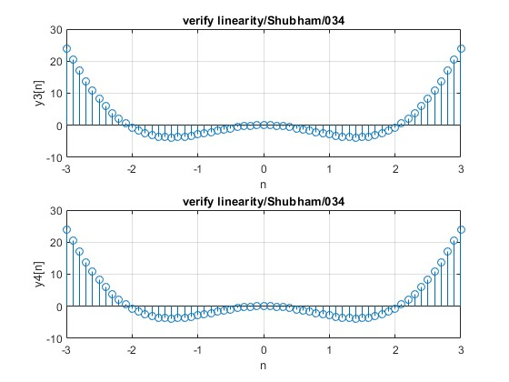

Q2. Two discrete signals are given as h[n]={1,2,1,-1} and x[n]={1,2,3,1}

Plot these two signals

1. Without using Convolution function

clc;

close all;

clear all;

h=[1 2 1 -1];

nh = [-1 0 1 2];

x= [1 2 3 1];

nx= [0 1 2 3];

X=[x,zeros(1,length(h))];

H=[h,zeros(1,length(h))];

n1=length(x);

n2=length(h);

for n=1:n1+n2-1

y(n) = 0;

for k=1:n1

if((n-k+1)>0)

y(n) =y(n)+X(k)*H(n-k+1);

end

end

end

n=min(nh)+min(nx):max(nh)+max(nx);

stem(n,y);

xlabel('n');

ylabel('y[n]');

title('Without convolution/Shubham/034');

grid on;

output:

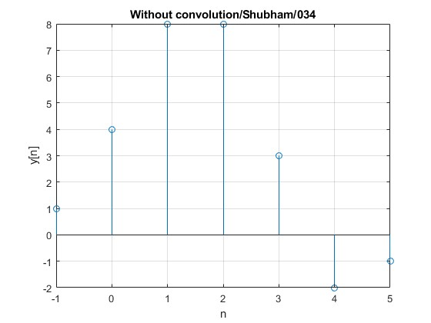

1. With Convolution function

clc;

close all;

clear all;

h=[1 2 1 -1];

nh = [-1 0 1 2];

x= [1 2 3 1];

nx= [0 1 2 3];

y= conv(x,h);

n=min(nh)+min(nx):max(nh)+max(nx);

stem(n,y);

xlabel('n');

ylabel('y[n]');

title('With convolution/Shubham/034');

grid on;

Output:

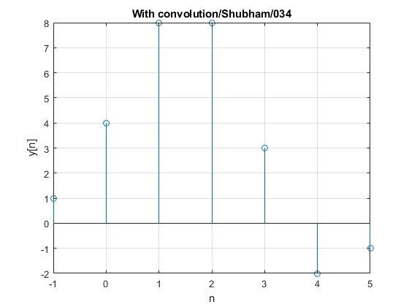

Q3. Find zeros, poles and gain of given transfer function using tf2zpk()

function and plot them

G(s) = 7s+5/s^2+4s+3

clc;

close all;

clear all;

num= [7 5];

den= [1 4 3];

[z,p,k] = tf2zp(num,den);

sys=tf(num,den);

pzmap(sys);

pzmap(p,z);

grid on;

sgrid;

output:

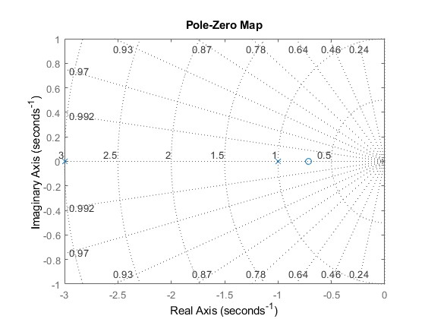

Q4. Plot the autocorrelation sequence of sine wave with frequency 1hz,

sampling frequency 200hz.

clc;

close all;

clear all;

A=1;

f=1;

fs=200;

w=2*pi*(f/fs);

t=0:0.001:1024;

x= A*sin(w*t);

subplot(2,1,1);

plot(t,x);

xlabel('t');

ylabel('x(t)');

title('Sine Wave/Shubham/034');

grid on;

y=xcorr(x);

subplot(2,1,2);

plot(y);

xlabel('t');

ylabel('y(t)');

title('Autocorrelation/Shubham/034');

grid on;

output:

